Low Level Design (REPORTS)

|  |  |  |  |  |
| --- | --- | --- | --- | --- |
| Prepared by/ Modified by | | Role | | Start Date – End Date |
| Rashmi Savla | | Team Lead | | 09 May 2014 –  23 May 2014 |
| Jagan Mohan Reddy C L | | SME | |  |
| Prithus Deb | | Point of Contact | |  |
| Nikhil Sawant | | Designer | |  |
| Praveen Choudhary | | ETL Developer | |  |
| Avinash Newton | | Data Modeler | |  |
| Reviewed by | | Role | | Date of Review |
| Rajita Dhumal | |  | | 14th May,2014 |
| Approved by | | Role | | Date of Approval |
| Swaroop Datta | |  | | 14th May,2014 |
| Circulation List | To all the ELTP mentors and the applicable trainee teams | | Version number of the template | **1.1** |
| **Version number of the work product** | V1.0 | | | |

Table of Contents

EXAMINATION & EVALUATION SYSTEM 0

1. INTRODUCTION 2

1.2 Document Scope 2

1.3Dependencies/Assumptions 2

2. Universe Design 3

3. classes and object 3

4. SAMPLE REPORTS 4

Revision History 4

# INTRODUCTION

This document will address the reporting processes to deliver the information from our data warehouse environment according to project requirement.

#### 1.1 Description of The Component

Reports present data that describe the activity of the project. Reports provide information about the current activity of the organization. Reports are generated with the help of reporting tool. A reporting tool is basically used for querying the data and presenting the data in different formats like tables, charts, cross tabs, etc. We are using QlikView as a reporting tool in our project.

# 1.2 Document Scope

This document will cover the logical design details related to generating reports for analytical use.

This document also includes

* The structure of reports.
* The fields of reports(dimensions and measures).
* Join logic between source tables for creation of the universe.

# 1.3 Dependencies/Assumptions

No provision shall be given to dynamically change the number of records in source files. Any authorized user will able to modify records for an employee.

**Assumption:**

* + - Data has already loaded properly into the data warehouse.
    - It is assumed that the data present in the database has been verified.
    - The Check constraints and cardinality between the dimensions table are already satisfied.

# Universe Design

The universe design for Examination and Evaluation System is as follows:

The tables for the universe creation is

* Dim_ACCOUNT
* Dim_bank_branch
* Dim_COMPANY
* Dim_DESIGNATION
* Dim_DOMAIN
* Dim_EDUCATION
* Dim_DESIGNATION
* Dim_LOAN
* Dim_MARITAL_STATUS
* Dim_PERSONAL

1. Fact table 1 consist of all the 7 colums and measures includes:

* PERSONAL_ID
* EMP_ID
* LOCATION_ID
* COMPANY_ID
* DESIGNATION_ID
* DOMAIN_ID
* LOAN_TYPE_ID
* BRANCH_ID

**Measures**

* CREDIT_CARD_NO
* DEBIT_CARD_NO
* EXPERIENCE
* SAVINGS_ACCOUNT_BALANCE
* INTERNET_BANKING
* REWARD_POINTS

1. Fact table 2 consist of all the 2 colums and measures includes:

* PERSONAL_ID
* ACCOUNT_TYPE_ID

**Measures**

* ACCOUNT_NUMBER
* ACCOUNT_OPENING_DATE

**Classes and Object**

* **ACCOUNT**- Account_Type_Id, Account_Type_Name
* **bank_branch**- Branch_Id, Branch_Location
* **COMPANY**– Company_Id, Company_Name
* **DESIGNATION**- Designation_Id, Designation_Name
* **DOMAIN**- Domain_Id, Domain_Name.
* **EDUCATION**- Education_Id, Education.
* **LOAN**- Loan_Type_Id, Loan_Type_Name, Rate_Of_Interest.
* **LOCATION**- location_Id, Location_Name.
* **MARITAL_STATUS**- Location_Id, Location_Name.
* **PERSONAL**- Personal_Id, Name, Age, Marital_Id, Phone_Number, Income, Housing, Voter_Id, Pan_Card, Address, Education_Id.

# SAMPLE REPORTS

1. Top ten bank accounts in terms of balance

**Dimensions -** ACCOUNT_NUMBER.

**Measures -** SAVINGS_ACCOUNT_BALANCE.

**Calculated Measures –**  Top 10 Account Balance

**Chart** –

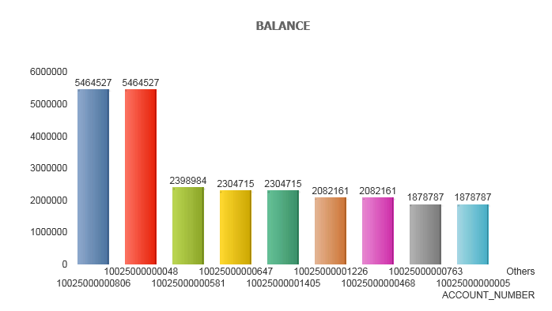

1. Analysis based on marital status and housing to provide loans.

**Dimensions –** MARITAL_STATUS_NAME

**Measures –** LOAN_TYPE_ID

**Calculated Measures –** COUNT( IF(LOAN_TYPE_ID=208, NO, YES))

**Chart** – 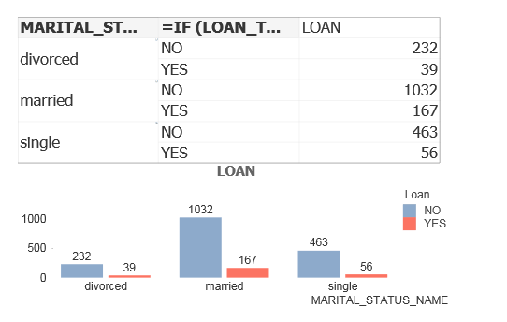

1. Analysis grouping on age and education

**Dimensions –** EDUCATION

**Measures –** AGE

**Calculated Measures –** COUNT(AGE)

**Chart**

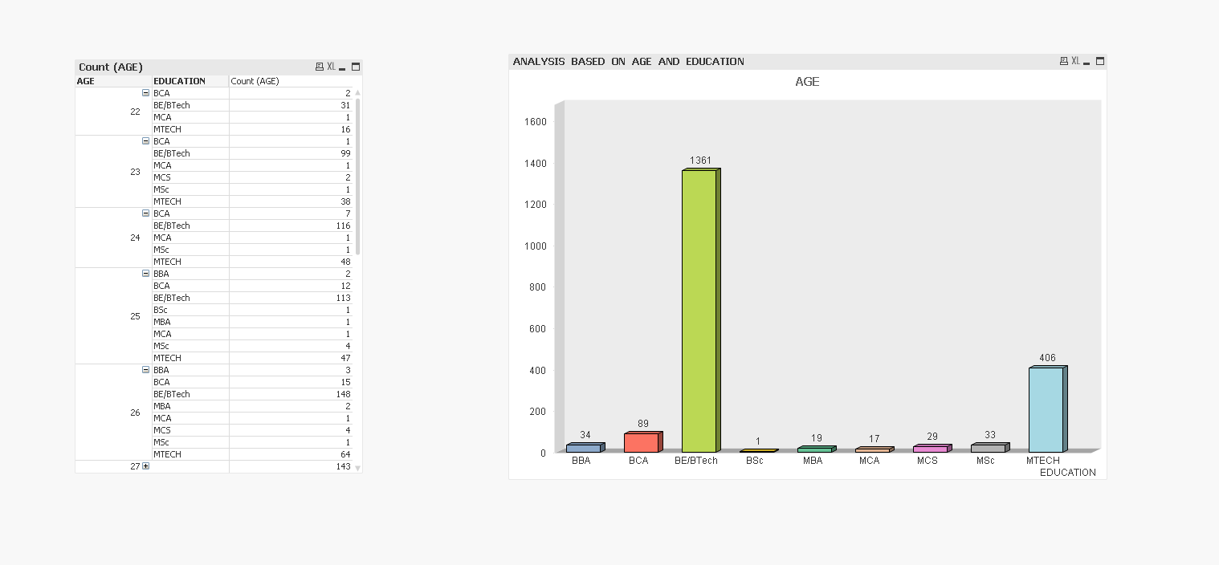

1. Based on no of account holders from the company –count of particular company

**Dimensions –** COMPANY_NAME

**Measures-**EMP_ID

**Calculated Measures –**COUNT(EMP_ID)

**Chart**

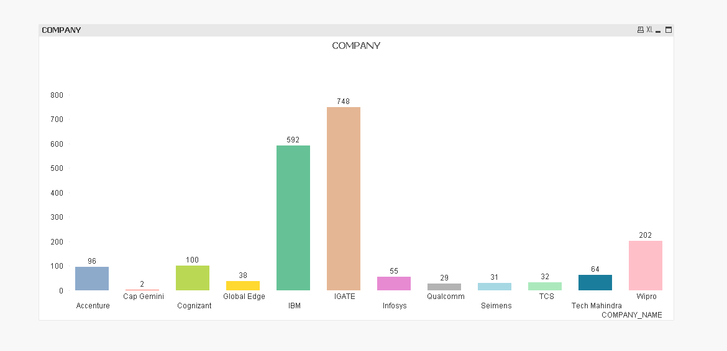

1. Based on account opening date

**Dimensions –** YEAR(ACCOUNT_OPENING_DATE)

**Measures –** COMPANY_NAME,ACCOUNT_NUMBER

**Calculated Measures-** COUNT(ACCOUNT_NUMBER)

**Chart**

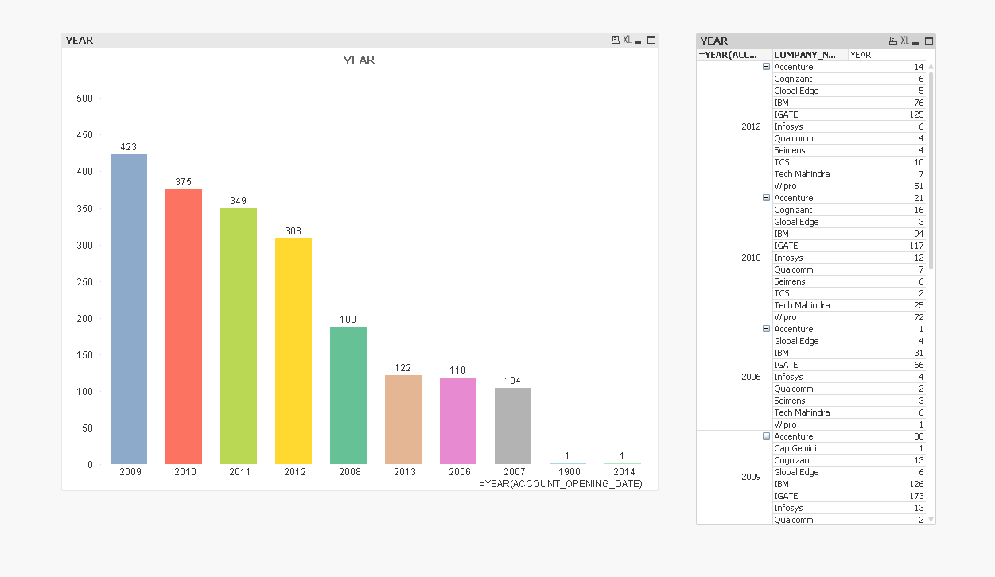

1. Based on income – income tax savings=(income-2lac)*tax%

**Dimensions –** YEAR(ACCOUNT_OPENING_DATE)

**Measures –** INCOME

**Calculated Measures-** (INCOME-2LAC)*16%

**Chart-**

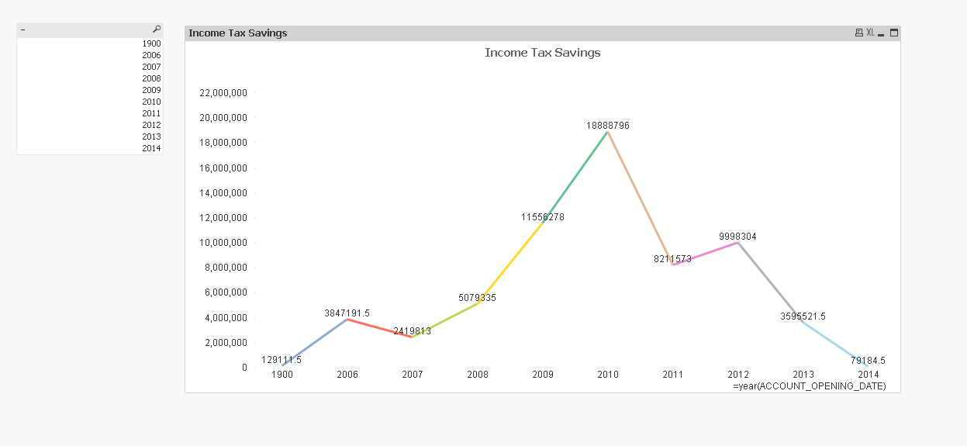

1. Based on age- retirement policies

**Dimensions**-EMP_AGE

**Measures**-EMP_ID

**Calculated Dimension**-IF(EMP_AGE>35,’LIC JEEVAN AKSHAY’,’SBI LIFE SARAL PLAN’ )

**Calculated Measures –**COUNT(EMP_ID)

**Chart** –

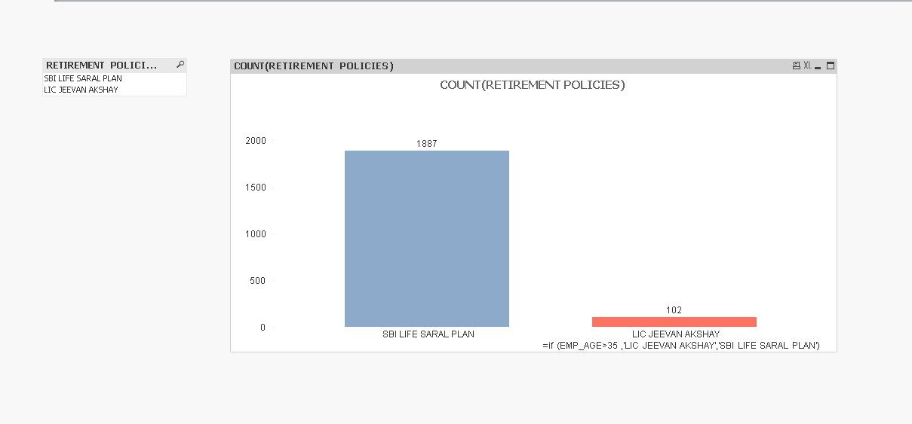

**8.** Based on experience – policies /offers=experience (based on their likings)

**Dimensions-EXPERIENCE**

**Measures**-EMP_ID

**Calculated Dimension**-IF(EXPERIENCE >=4,’PROMOTION’,’TRAVEL ALLOWANCE’ )

**Calculated Measures –**COUNT(EMP_ID)

**Chart** –

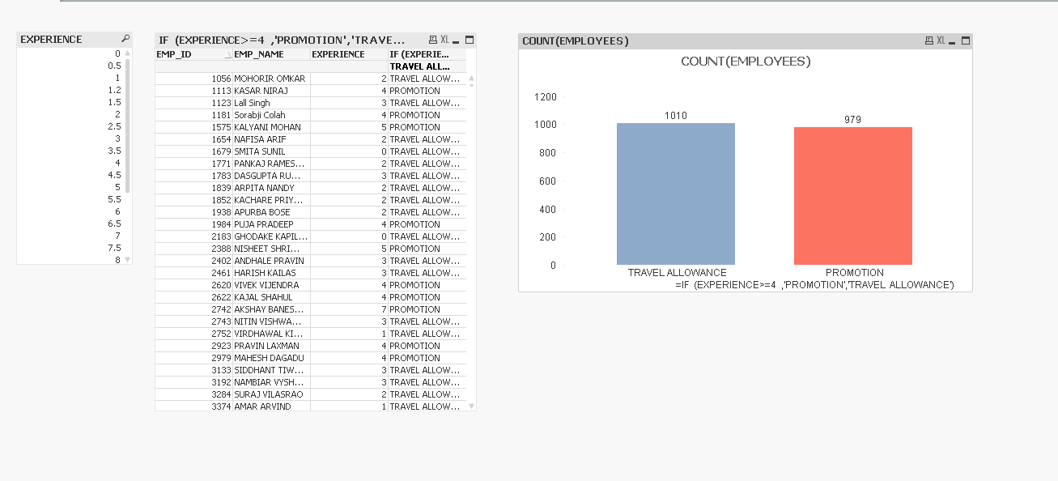

9. Based on region to establish more banking portals-count of all locations

**Dimensions-** BANK_BRANCH

**Measures**-EMP_ID

**Calculated Measures –**COUNT(EMP_ID)

**Chart** –

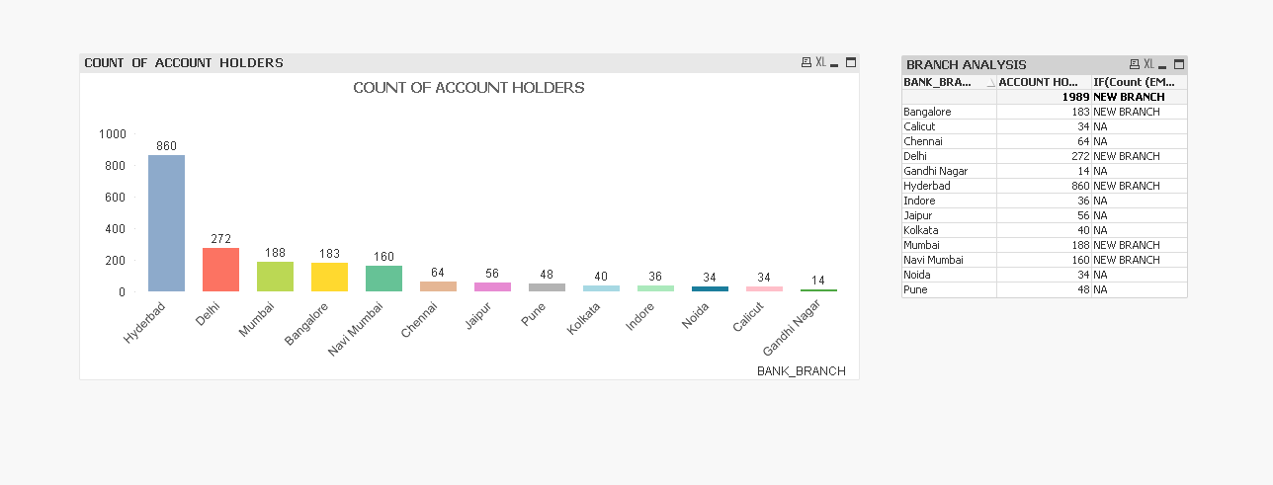

10. Based on reward points – offers

**Dimensions-**REWARD_POINTS

**Measures**-EMP_ID

**Calculated Dimension**-IF(REWARD_POINTS>=6000,IF(REWARD_POINTS>=20000,’5000’,’1000’),’NA’)

**Calculated Measures –**COUNT(EMP_ID)

**Chart** –

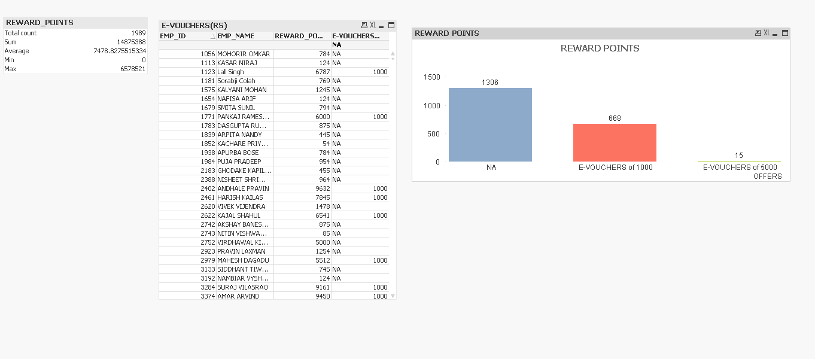

11. no. of similar types of account –count of all same types of Based on accounts

**Dimensions-**ACCOUNT_TYPE

**Measures**-ACCOUNT_NUMBER

**Calculated Measures –**COUNT(ACCOUNT_NUMBER)

**Chart** –

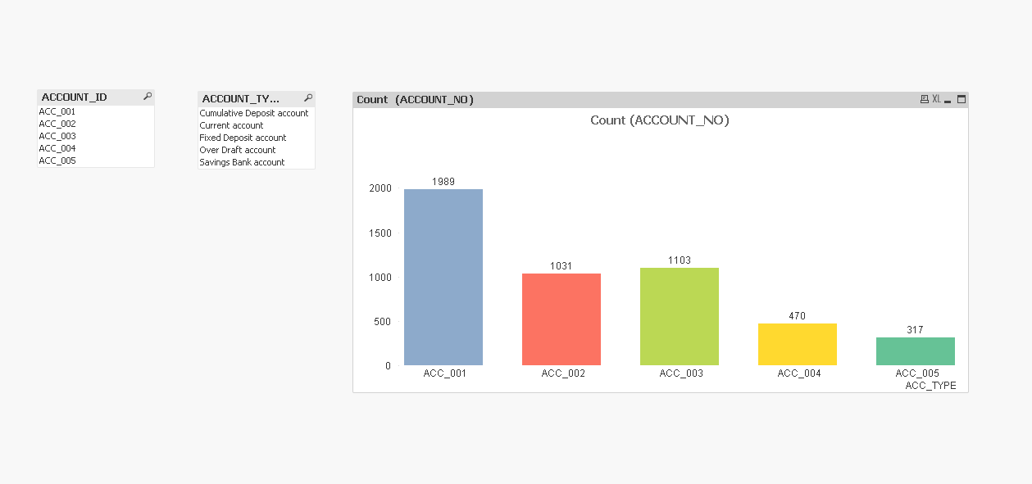

# Revision History

|  |  |  |  |  |
| --- | --- | --- | --- | --- |
| **#** | **Date** | **Version #** | **Section / Page# changed** | **Details of changes made** |
| 1. | 15-May-2014 | V1.0 | Entire Document | Approved version of the LLD |